**Lesson 1 Guide**

Adding an Email signature

* 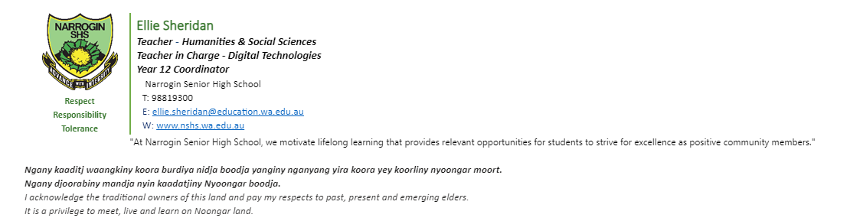At the bottom of your teachers emails (and other companies) there is often an email signature. Email signatures include information about the person, the company and their role.
* Your task today will be to add your own.
* 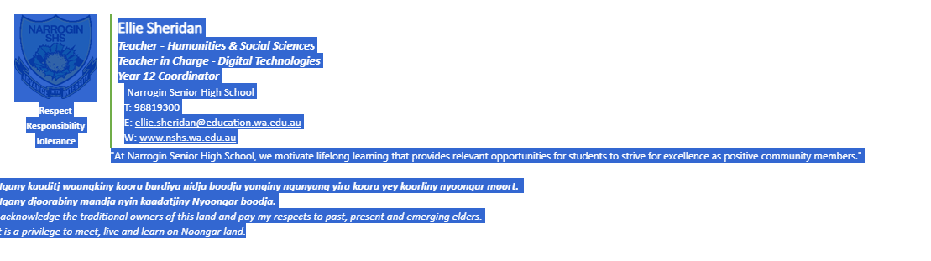Highlight and Copy the email signature from the bottom of Miss Sheridan’s email. By dragging your mouse over, ensure all of the signature is selected.
* Select the settings icon on the top right of the email page (on Google Chrome)

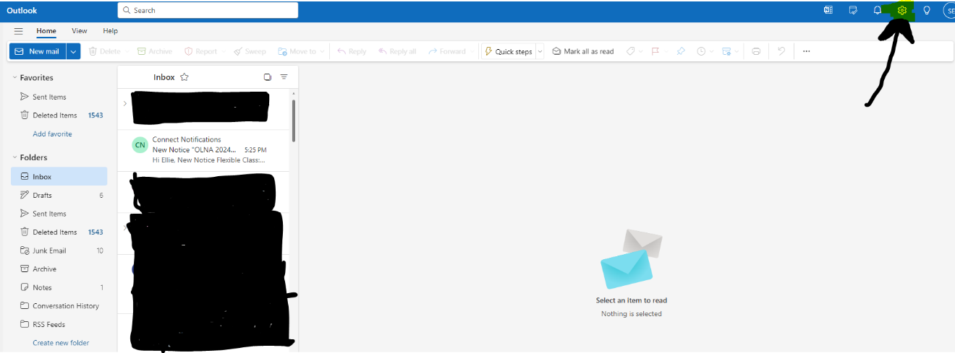

-search for signature in the search bar on the left hand side and select Email Signature

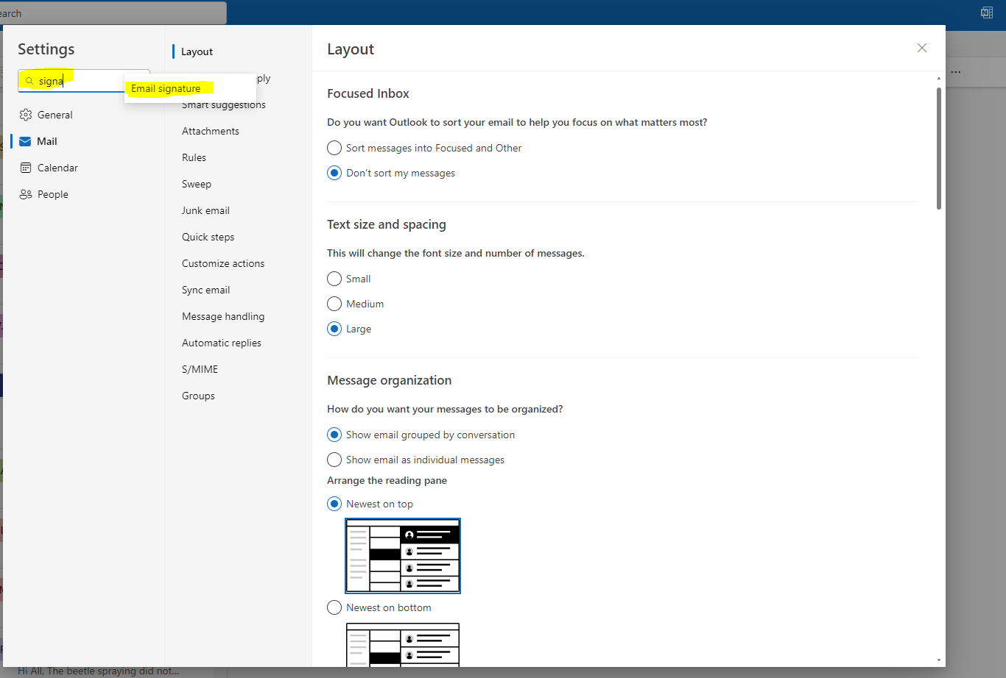

* Paste the signature into the empty text box. Change the information to be your own.
  + Name
  + Year 10 Student
  + Email ([first.surname@student.education.wa.edu.au](mailto:first.surname@student.education.wa.edu.au))
* Name the signature and click save
* Ensure the boxes for new messages and for replies/forwards are selected with the name of your email. Click save again.

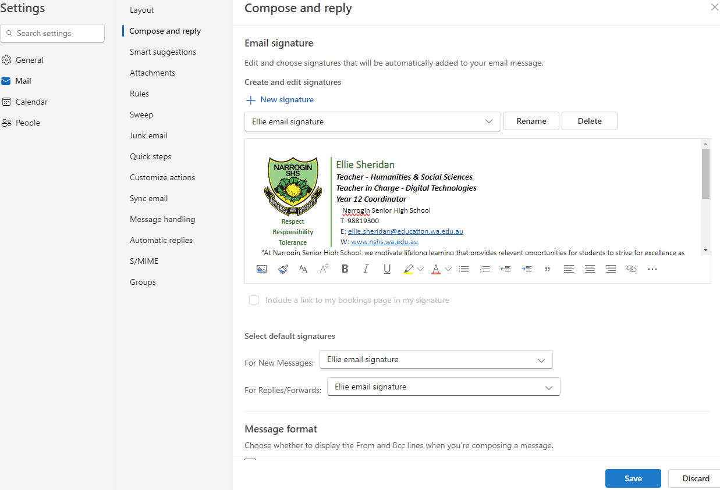

* Click New mail. Add my email ([ellie.sheridan@education.wa.edu.au](mailto:ellie.sheridan@education.wa.edu.au)) add the subject Test and say Hi. Click send.
* All emails should have a subject line, a greeting and finish with a sign off like kind regards.

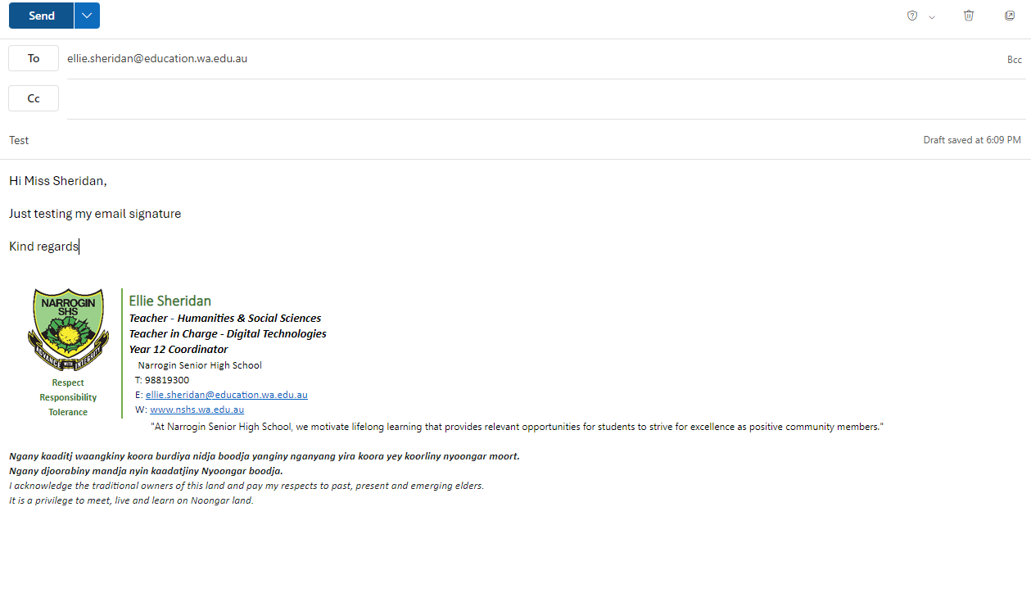

Activity 2: Setting Up Folders

* Select the folder icon at the bottom of your screen (click it)
* 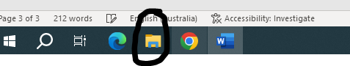
* 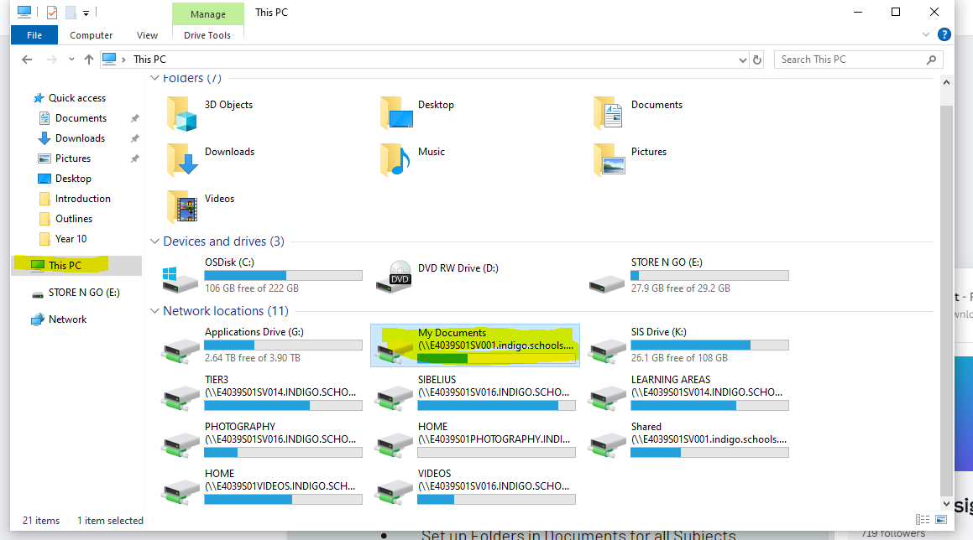Click on This PC then click on My Documents
* Select the New Folder Icon in the Top Left

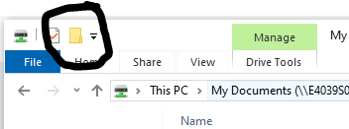

* Name this folder Year 10
* Using the My Folder Icon Create a folder for all of your subjects.

Activity 3: Connect Assessment Outline

* Log onto Connect and select the class called Digital Citizenship or 10DC_1
* Click onto the Library Icon on the Left Hand Side

Open the folder called Assessment Outlines

* Download the file called “Year 10 Digital Tech Assessment Outline Sem 1)
* Open the download and save the file to your Year 10 Digital Citizenship Folder that you would have just created.
* Remember you may have to click save as and then select This PC and then My Documents. If your files you have just created aren’t coming up then you are in the wrong location.

Activity 4: Adding a Calendar Event

* Go back to your emails
* Select the Calendar option underneath the blue envelope on the left hand side.

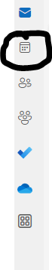

* Select Friday the 9th of February.
* Double click on that date.
* Add the information for the event. In this case
  + 10 Digital Citizenship
  + Select the time (11.30-12.30)
  + Location: Room 10.
* Then click save. The event will now appear on your calendar.

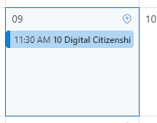

* Then add other important events to your calendar like your birthday etc.